CHARLIEPLEXING USING ARDUINO

***A MINOR PROJECT REPORT***

*Submitted in Partial Fulfillment of the Requirements for*

# Microprocessors and Interfacing

By

# D.Navya Sree (181FA04014)

**V.SaiLalithya (181FA04058)**

**G.Tarunya (181FA04139)**

*Under the Esteemed Guidance of*

**Mr. M.Krishna Chennakesava Rao, M. E. (Ph.D) .**

**Assistant professor**



(ACCREDITED BY **NAAC** WITH **‘A’** GRADE)

**DEPARTMENT OF COMPUTER SCIENCE & ENGINEERING**

**Vignan’s Foundation for Science,Technology & Research**

Deemed to be University

**Vadlamudi, Guntur - 522213, INDIA.**

**CERTIFICATE**

This is to certify that the report entitled “CHARLIPLEXING USING AURDINO”is submitted by **Navyasree(181FA04014), Lalithya(181FA04058), Tarunya(181FA04139)”** in the partial fulfilment of course work of Microprocessors and Interfacing as a minor project, carried out in the department of CSE ,VFSTR deemed to be university.

|  |  |  |
| --- | --- | --- |
| **SIGNATURE** |  | **SIGNATURE** |
| **Dr. VenkatesuluDondeti,** |  | **Mr. M.Krishna Chennakesava Rao, M. E. (Ph.D) ,** |
| **HEAD OF THE DEPARTMENT**  Professor |  | Assistant Professor |
|  |  |  |

Submitted for the External Review held on ……………………….

**InternalExaminer ExternalExaminer**

# TABLE OF CONTENTS

|  |  |  |
| --- | --- | --- |
| **S.NO** | **TOPIC** | **Page Number** |
| 1 | Objective |  |
| 2 | Abstract |  |
| 3 | Introduction |  |
| 4 | Block Diagram & Explanation |  |
| 5 | Hardware interfacing Connections. |  |
| 6 | DataSheet |  |
| 7 | Working principle |  |
| 8 | Implementation |  |
| 9 | Conclusion |  |

**1.OBJECTIVE**

The Main Objective of this project is to implement Charliplexing using Arduino.In this a Multiplexed display is generated in which relatively few I/O pins on a microcontroller are used e.g. to drive an array of LEDs.

**2.ABSTRACT**

Charlieplexing is same as multiplexing, but it uses the tri-state logic (high, low input) to reduce the number of pins dramatically and to gain efficiency over multiplexing. The Charlieplexing technique is named after its inventor, Charlie Allen, who invented the technique in 1995.

Charlieplexing is that driving lots of LEDs with only a few pins. And in this Project we drive 6 LEDs using 3 pins. This method of Charlieplexing uses the tri-state logic capabilities of micro-controllers in order to gain efficiency over traditional multiplexing. This is another form of multiplexing.

# 3.INTRODUCTION

Charlieplexing is a technique of controlling many LEDs using a few I/O pins. Charlieplexing is same as multiplexing, but it uses the tri-state logic (high, low input) to reduce the number of pins dramatically and to gain efficiency over multiplexing. The Charlieplexing technique is named after its inventor, Charlie Allen, who invented the technique in 1995. We previously used multiplexing technique in arduino to [interface 4-digit 7-segment display](https://circuitdigest.com/microcontroller-projects/arduino-7-segment-display-clock) and [driving 8x8](https://circuitdigest.com/microcontroller-projects/scrolling-text-display-on-8x8-led-matrix-arduino) [LED matrix.](https://circuitdigest.com/microcontroller-projects/scrolling-text-display-on-8x8-led-matrix-arduino) Charlieplexing allows you to control N * (N – 1) LEDs, where N is the no of pins. For example, you can control 12 LEDs using 4 Arduino pins 4*(4-1) =12. LEDs are diodes, and in diodes, current flows in only one direction. So in Charlieplexing, we connect two LEDs in parallel with each other but with opposite polarity so that only one LED turn on at a time. When it comes to Arduino or other microcontroller boards, you never have enough input/output pins. If you are working on a project in which you need to interface [LCD display,](https://circuitdigest.com/article/16x2-lcd-display-module-pinout-datasheet) a bunch of LEDs, and some sensors, then you are already out of pins. In that situation, you can charlieplex LEDs to reduce the number of pins.

**NodeMCU:**

The NodeMCU (Node MicroController Unit) is an open source software and hardware development environment that is built around a very inexpensive System-on-a-Chip (SoC) called the ESP8266.

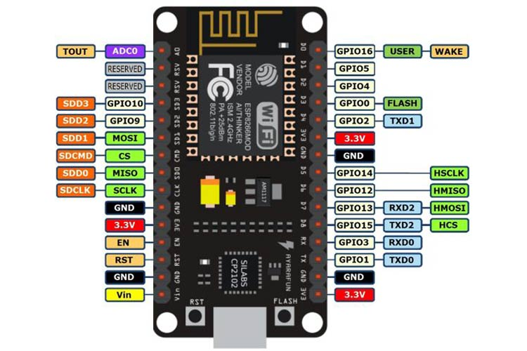

NodeMCU provides a more consistent and accessible experience for IoT developers. **Applications of NodeMCU**

Prototyping of IoT devices Low power battery operated applications Network projects Projects requiring multiple I/O interfaces with Wi-Fi and Bluetooth functionalities.

**Raspberry Pi:**

The Raspberry Pi is a low cost, credit-card sized computer that plugs into a computer monitor or TV, and uses a standard keyboard and mouse. It is a capable little device that enables people of all ages to explore computing, and to learn how to program in languages like Scratch and Python.

An SD card inserted into the slot on the board acts as the hard drive for the Raspberry Pi. It is powered by USB and the video output can be hooked up to a traditional RCA TV set.

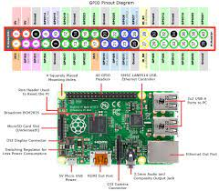

**Applications:**

Replace Your Desktop PC With a Raspberry Pi.

Print With Your Raspberry Pi. ... Add AirPrint Support to Your Pi Print Server.

**Arduino Uno:**

The Arduino UNO is the best board to get started with electronics and coding. If this is your first experience tinkering with the platform, the UNO is the most robust board you can start playing with. The UNO is the most used and documented board of the whole Arduino family.

Arduino Uno is a microcontroller board based on the ATmega328P (datasheet). It has 14 digital input/output pins (of which 6 can be used as PWM outputs), 6 analog inputs, a 16 MHz ceramic resonator (CSTCE16M0V53-R0), a USB connection, a power jack, an ICSP header and a reset button. It contains everything needed to support the microcontroller; simply connect it to a computer with a USB cable or power it with a AC-to-DC adapter or battery to get started.. You can tinker with your Uno without worrying too much about doing something wrong, worst case scenario you can replace the chip for a few dollars and start over again. "Uno" means one in Italian and was chosen to mark the release of Arduino Software (IDE) 1.0. The Uno board and version 1.0 of Arduino Software (IDE) were the reference versions of Arduino, now evolved to newer releases. The Uno board is the first in a series of USB Arduino boards, and the reference model for the Arduino platform; for an extensive list of current, past or outdated boards see the Arduino index of boards.

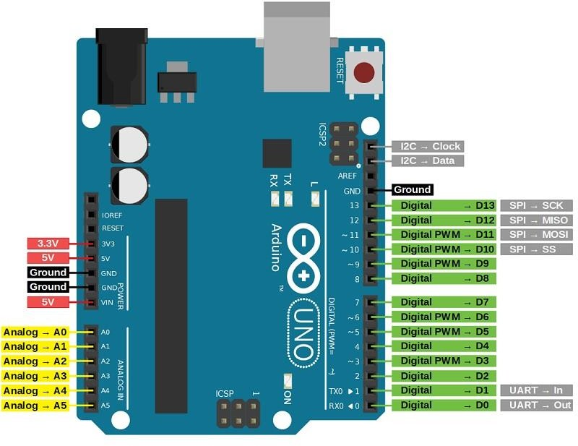

**Applications of Arduino Uno**

Arduino Uno is used in Do-it-Yourself projects prototyping. In developing projects based on code-based control. Development of Automation System. Designing of basic circuit designs.

**Comparision between Arduino and Node MCU:**

The Arduino project creates an open source hardware design and software SDK for a versatile IoT controller. Similar to NodeMCU, the Arduino hardware is a microcontroller board with a ready USB connector, LED lights, and standard data pins. It also defines standard interfaces to interact with sensors or other boards. But unlike NodeMCU, the Arduino board can have different types of CPU chips (typically an ARM or Intel x86 chip) with memory chips, and a variety of programming environments.

In fact there is an Arduino reference design for the ESP8266 chip as well. However, the flexibility of Arduino also means significant variations across different vendors. For example, most Arduino boards do not have wifi capabilities and some even have a serial data port instead of a USB port. I feel that NodeMCU provides a more consistent and accessible experience for IoT developers.

**Comparision between Arduino and Raspberry pi:**

They're both small, they're both powerful, and they both get used in electronics hobby projects, but the Raspberry Pi is not an Arduino. ... Using the tips in this article, you can use the Pi as a testbed for future Arduino projects, or you can have the best of both worlds all in one device.

The Microcontroller on the Arduino board contains the CPU, RAM and ROM. All the additional hardware on Arduino Board is for power supply, programming and IO Connectivity. Raspberry Pi SBC has all features of a computer with a processor, memory, storage, graphics driver, connectors on the board. Raspberry Pi needs an Operating System to run. Arduino doesn’t need any operating system. All you need is a binary of the compiled source code. Raspberry Pi comes with a fully functional operating system.

**4.BLOCK DIAGRAM**

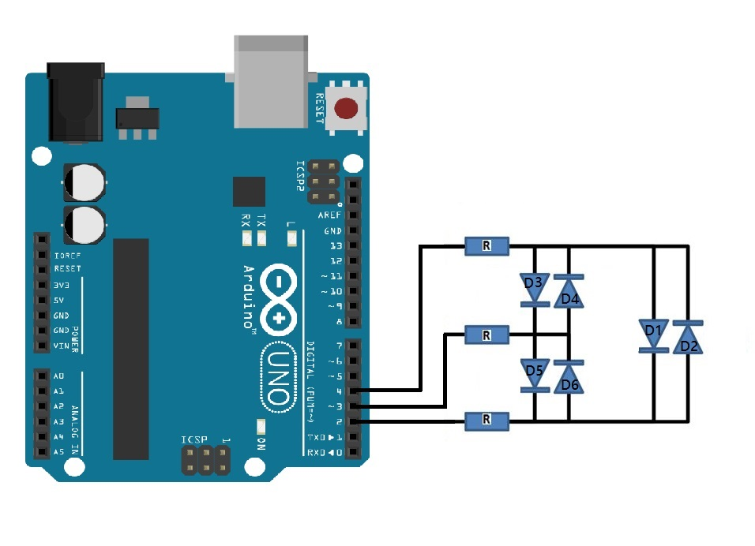

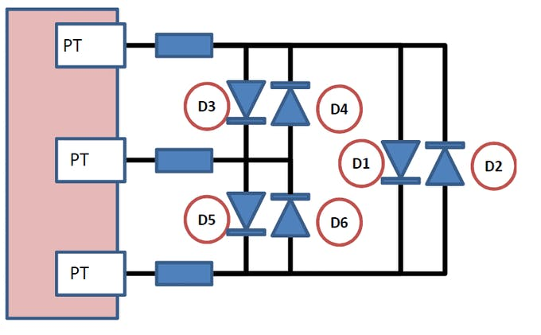

**Explanation:**

Charlieplexing allows you to control N * (N – 1) LEDs, where N is the no of pins. For example, you can control 6 LEDs using 3 Arduino pins 3*(3-1) =6. LEDs are diodes, and in diodes, current flows in only one direction. So in Charlieplexing, we connect two LEDs in parallel with each other but with opposite polarity so that only one LED turn on at a time. When it comes to Arduino or other microcontroller boards, you never have enough input/output pins. If you are working on a project in which you need to interface LCD display, a bunch of LEDs, and some sensors, then you are already out of pins. In that situation, you can charlieplex LEDs to reduce the number of pins. In this project, we are going to use the Charlieplexing technique to control the 6 LEDs using 3 Arduino pins.

**5.Hardware Interfacing**

## COMPONENTS REQUIRED

* Arduino UNO
* Breadboard
* LED(6)
* Jumper Wires
* Resistors(3) -330 ohm

## ARDUINO UNO SPECIFICATIONS

* Operating Voltage: 5 Volts
* Input Voltage: 7 to 20 Volts
* Digital I/O Pins: 14 (of which 6 provide PWM output)
* Analog Input Pins: 6
* DC Current per I/O Pin: 20 mA
* DC Current for 3.3V Pin: 50 mA
* [Flash Memory](https://en.wikipedia.org/wiki/Flash_Memory): 32 KB of which 0.5 KB used by [bootloader](https://en.wikipedia.org/wiki/Booting#BOOT-LOADER)
* [SRAM](https://en.wikipedia.org/wiki/Static_random-access_memory): 2 KB
* [EEPROM](https://en.wikipedia.org/wiki/EEPROM): 1 KB
* Clock Speed: 16 MHz
* Length: 68.6 mm
* Width: 53.4 mm
* Weight: 25 g

## Bread board

A breadboard is a solder less device for temporary prototype with electronics and test circuit designs. Most electronic components in electronic circuits can be interconnected by inserting their leads or terminals into the holes and then making connections through wires where appropriate. The breadboard has strips of metal underneath the board and connect the holes on the top of the board. The metal strips are laid out as shown below. Note that the top and bottom rows of holes are connected horizontally and split in the middle while the remaining holes are connected vertically.

* 1. **Circuit Diagram**

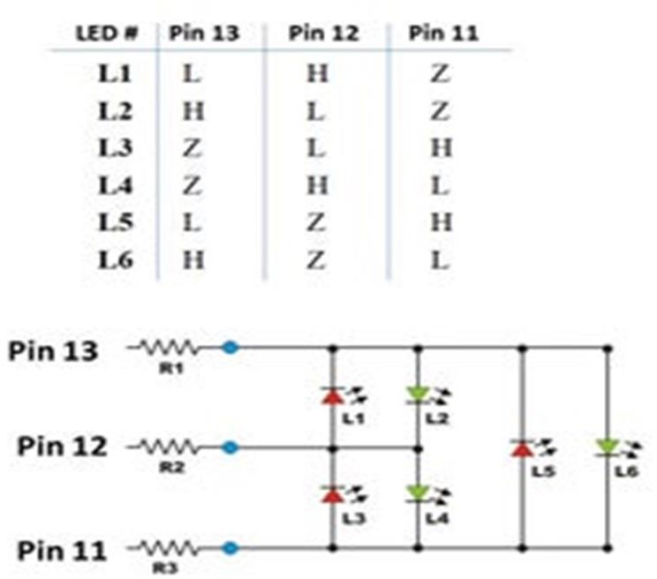

**5.4 LED**

A light-emitting diode (LED) is a [semiconductor](https://en.wikipedia.org/wiki/Semiconductor) [light source](https://en.wikipedia.org/wiki/Light_source) that emits light when [current](https://en.wikipedia.org/wiki/Electric_current) flows through it. [Electrons](https://en.wikipedia.org/wiki/Electron) in the semiconductor recombine with [electron holes](https://en.wikipedia.org/wiki/Electron_hole), releasing energy in the form of [photons](https://en.wikipedia.org/wiki/Photon). The color of the light (corresponding to the energy of the photons) is determined by the energy required for electrons to cross the [band gap](https://en.wikipedia.org/wiki/Band_gap) of the semiconductor. White light is obtained by using multiple semiconductors or a layer of light- emitting phosphor on the semiconductor device.

## 5.5 Resistors

A **resistor** is a [passive](https://en.wikipedia.org/wiki/Passivity_(engineering)) [two-terminal](https://en.wikipedia.org/wiki/Terminal_(electronics)) [electrical component](https://en.wikipedia.org/wiki/Electronic_component) that implements [electrical](https://en.wikipedia.org/wiki/Electrical_resistance) [resistance](https://en.wikipedia.org/wiki/Electrical_resistance) as a circuit element. In electronic circuits, resistors are used to reduce current flow, adjust signal levels, to divide voltages, [bias](https://en.wikipedia.org/wiki/Biasing) active elements, and terminate [transmission lines](https://en.wikipedia.org/wiki/Transmission_line), among other uses. High-power resistors that can dissipate many [watts](https://en.wikipedia.org/wiki/Watt) of electrical power as heat, may be used as part of motor controls, in power distribution systems, or as test loads for [generators.](https://en.wikipedia.org/wiki/Electric_generator)

**7.Working Principle**

Basically, in this circuit diagram, 6 LEDs are connected with Arduino pins through resistors. There are three groups of LEDs, and in each group, 2 LEDs are connected, and both LEDs are parallel with each other but with opposite polarity so that only one LED turn on at a time. So according to the circuit diagram to turn on led 1, there needs to be a HIGH signal on pin A and a LOW signal on pin B, and pin C and D needs to be disconnected. The same procedure will be followed for the other LEDs.

**8.Implementation**